Week6 HW-3

Q2:

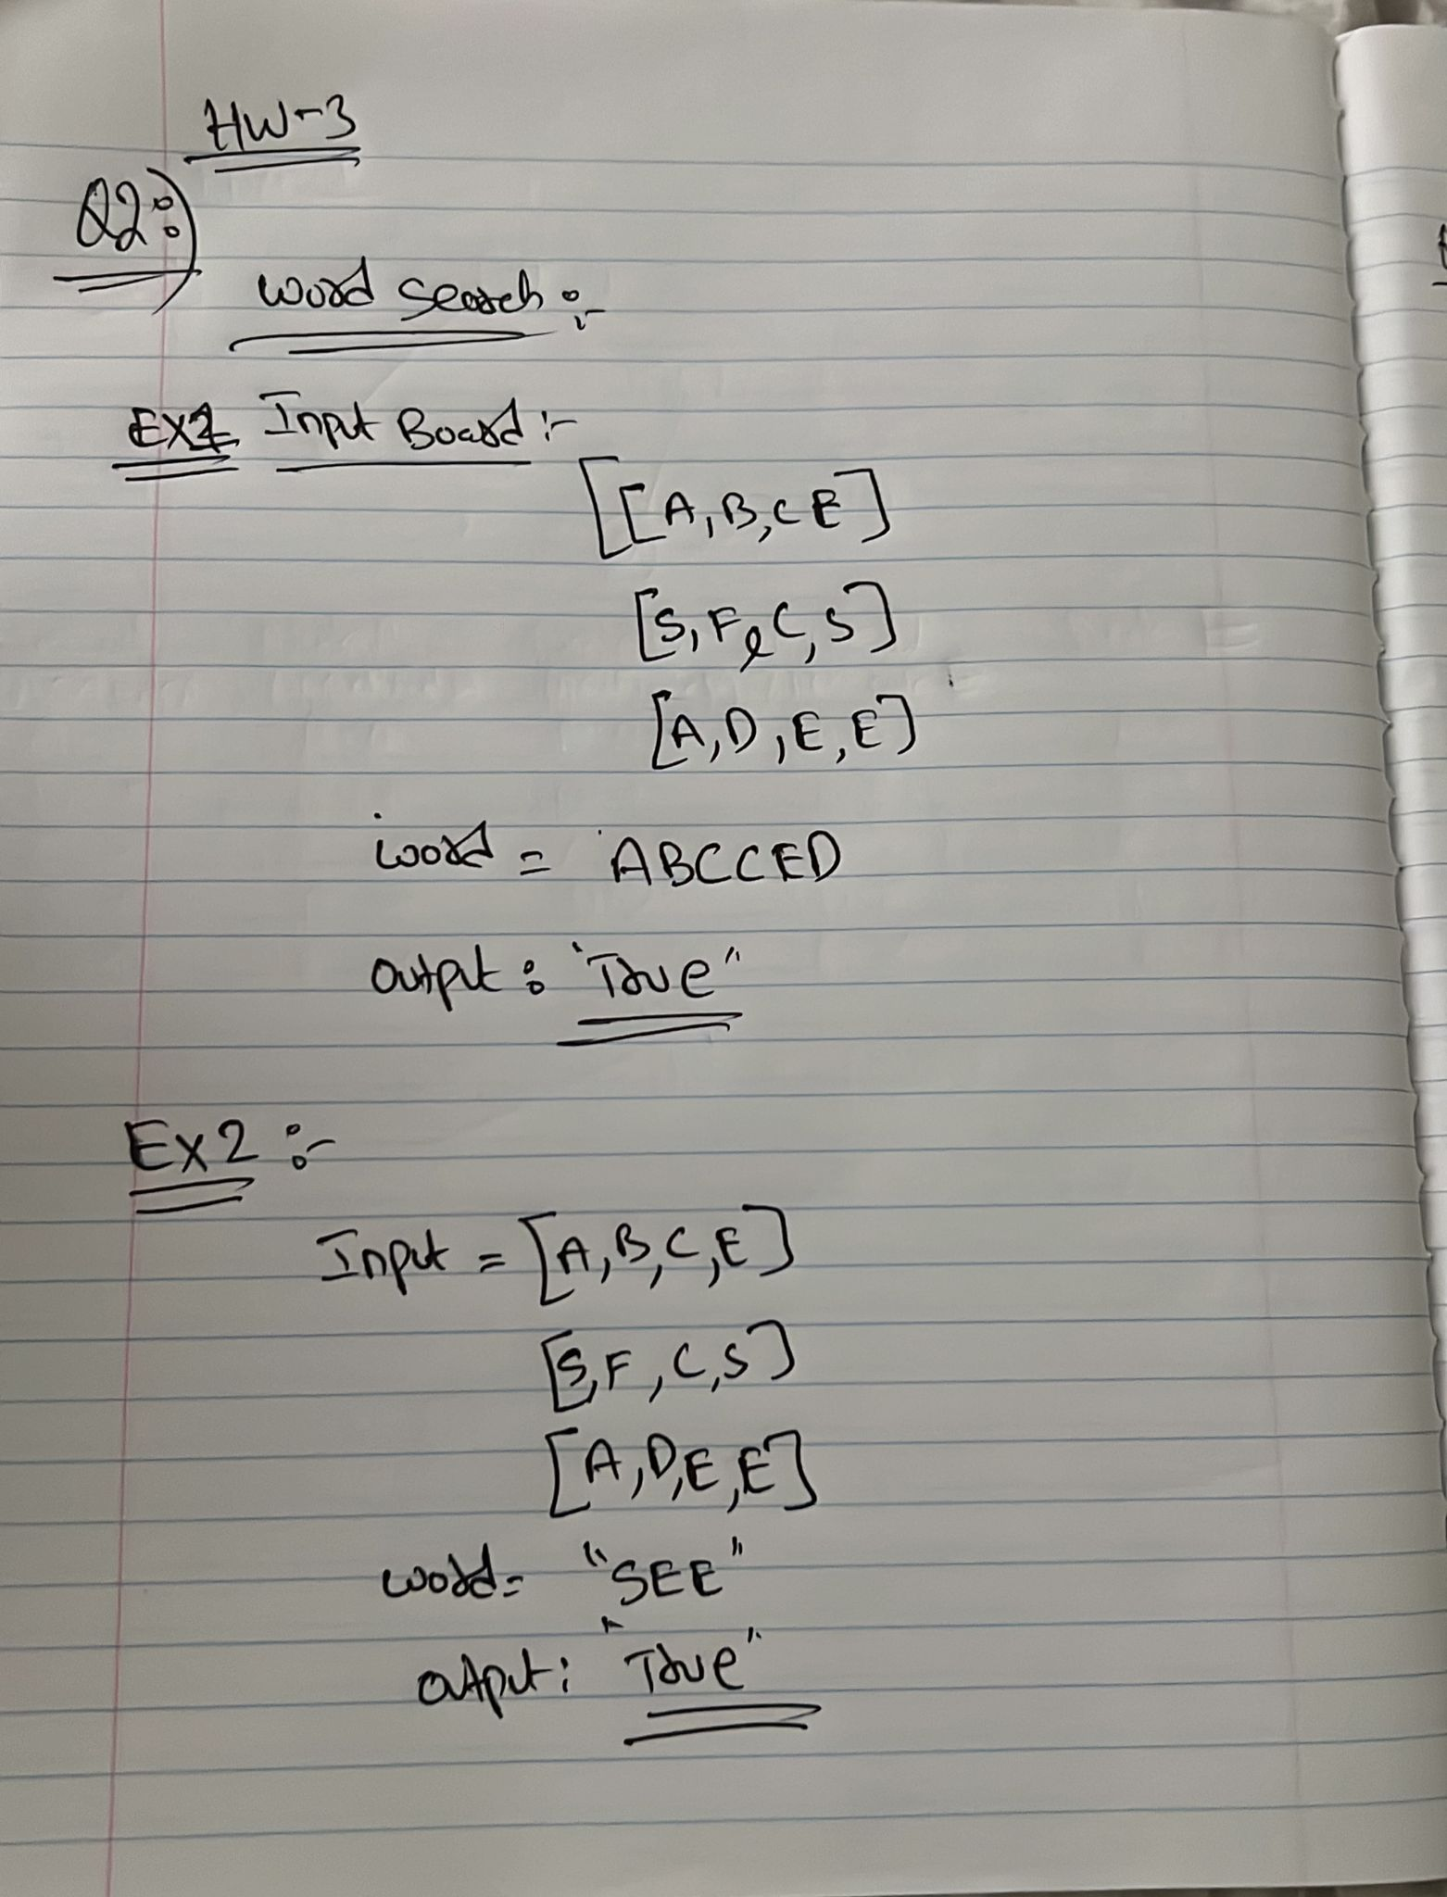

ChatGPT code:

Test code:

Output:

